UBC Badminton Club

Are you yearning to pick up a new sport? Or are you just itching to find a place to play badminton again? If you want to meet some new people and play badminton, this could be the club for you.
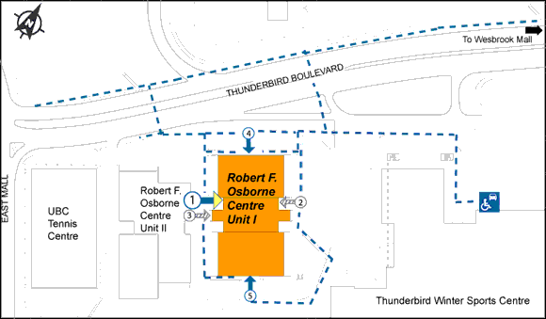
We have players in every level so you don't have to worry about finding some one to play against or with. Whether your school budget prevents you from purchasing a racquet or your badminton bag costs more than your text books for the year, we will have a place for you.
Enter through door #1 during gym nights, and we’ll be located on your left.

UBC Badminton Club
Are you yearning to pick up a new sport? Or are you just itching to find a place to play badminton again? If you want to meet some new people and play badminton, this could be the club for you.
We have players in every level so you don't have to worry about finding some one to play against or with. Whether your school budget prevents you from purchasing a racquet or your badminton bag costs more than your text books for the year, we will have a place for you.
Enter through door #1 during gym nights, and we’ll be located on your left.
Membership Costs?

New Members: $50
Returning Members: $40

What you Get?
Access to Yonex nylon shuttles, free rental racquets, members-only tournament (included with membership), and friendly execs! ☺

Where to show off the Skillz?
Osbourne Centre – Gym A

Gym Times?
Term 1: Sept. 23 to Nov. 28
Tuesdays 4:00pm to 6:00pm
Fridays 6:30pm to 11:00pm

Term 2: TBD
Tuesdays TBD
Fridays TBD

Facebook: UBC Badminton Club

Website: http://www.ams.ubc.ca/clubs/badminton
E-mail us @ ubc.badm@gmail.com for more info!

Membership Costs?

New Members: $50
Returning Members: $40

What you Get?
Access to Yonex nylon shuttles, free rental racquets, members-only tournament (included with membership), and friendly execs! ☺

Where to show off the Skillz?
Osbourne Centre – Gym A

Gym Times?
Term 1: Sept. 23 to Nov. 28
Tuesdays 4:00pm to 6:00pm
Fridays 6:30pm to 11:00pm

Term 2: TBD
Tuesdays TBD
Fridays TBD

Facebook: UBC Badminton Club
Website: http://www.ams.ubc.ca/clubs/badminton
E-mail us @ ubc.badm@gmail.com for more info!

